
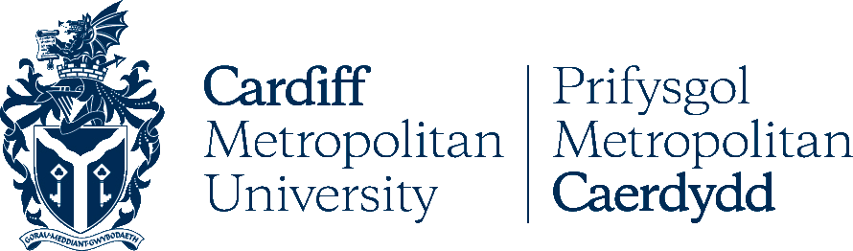
This is to certify that:

And Cardiff Metropolitan University collaborate in relation to the facilitation of advanced entry to a relevant 3+1 program based on Accredited Prior Learning at Ly Tu Trong Technical College Ho Chi Minh City or to a Postgraduate Masters programme based on completion of the aforementioned program by overseas students.

* Students must meet all entry requirements as stated in MOA.
Cardiff Metropolitan University Ly Tu Trong Technical College HCM City
Signature Signature

Date: 25th February 2016

Ly Tu Trong Technical College Ho Chi Minh City

